Advanced : The MyLevel Package

Reload this article and prepare it for printing.
(removes banner ad and menubar and sets new width for page)
This article was last updated on Tuesday, January 29, 2002
Written by:
Anthony `Bean` Nichols
bean@planetunreal.com
Importing `MyLevel` Package Objects
This tutorial are for those who are comfortable with UnrealEd. There is a lot of lingo used in here.
The `MyLevel` package is valuable for those who do not want to distribute textures, sounds, music, and other media objects in seperate files along with their maps. When using the `MyLevel` package, textures, sounds, .u packages, etc can be embedding directly into your .unr file so there is no extra files to zip up along with your map when distributing. Many mappers find this to be VERY handy.
-MyLevel Textures and Screenshot
To import textures into the `MyLevel` package, open the texture browser and select File->`Import`.
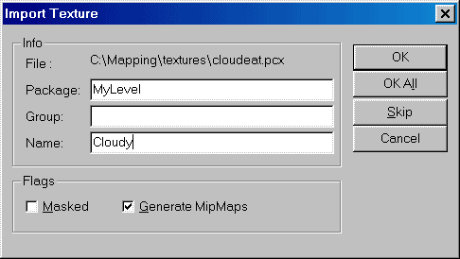
In the Import Texture dialog, enter in MyLevel for the package. Enter in whatever name or group that you would like. If it is masked, don`t forget to check the masked box. Then, click OK. Don`t save the package. Now, apply the imported texture onto a surface, then do a full rebuild. Now, when you save your map, the texture will stay with your level. Make sure you apply any MyLevel textures to a surface before you rebuild or it will be discarded by UnrealED. When you want to access your `MyLevel` textures, just open the texture browser and use the pull-down list.
When importing a Screenshot for your level, make sure that you enter `ScreenShot` as the texture name and uncheck Generate MipMaps.
-MyLevel Meshes
This is fairly easy. Make sure your mesh is ready and packed into a .u file. Place the .u file into the UnrealTournament\System directory. Then, in the command console of UnrealED type:
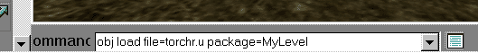
obj load file=nameoffile.u package=MyLevel
Substitute the nameoffile with the name of the .u package. Then, add the mesh into the level and do a full rebuild. When you save, it will be embedded.
-MyLevel Sound and Music
For sound:
Open up the Sounds Broswer and click File->Import. Select the sound that you would like to import. When the dialog comes up, enter MyLevel for the package. Then click OK. Use the sound in the map, do a full rebuild, then save.
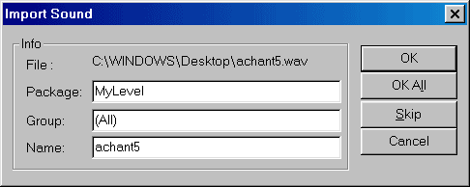
For music:
Open up the music browser. Go to File->Import. Choose the song you would like to import. When the dialog comes up, enter the name MyLevel and hit OK. Next, goto level properties by pressing F6. Then, got to the list titled `Audio`. Having your song selected in the Music Browser, click `Use` under the song line. Do a full rebuild, then save.
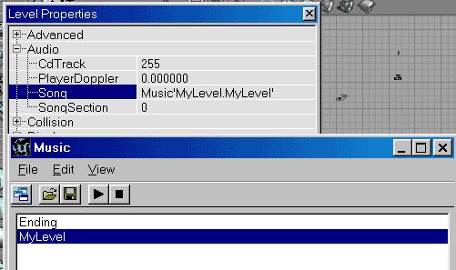
That`s all there is to MyLevel! Pretty simple, huh?
~Anthony `Bean` Nichols

